

Topic test 1
Name: __________________________________

Chapter 4: Functions and graphs

- Time allowed: 45 minutes
- CAS calculators may be used.
- Part A: 5 multiple-choice questions (5 marks)
- Part B: 7 short answer questions (49 marks)
- Part C: 2 analysis questions (16 marks)
Part A
5 multiple-choice questions
1 mark each: 5 marks
Circle the correct answer.
1 Which of the following is NOT a function?
A y  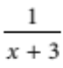
B x  y 2  7y  1
C x2  y  1  0
D 3x  y  1  0
E y  x4  8

[1 mark]
2 Which function is discontinuous?
A y  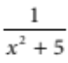
B y  x2  5
C f(x)  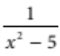
D f(x)  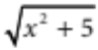
E y  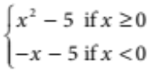

[1 mark]
3 Which is the equation of the function 2 units to the right of y  x3 and 3 units up?
A y  (x  2)3  3
B y  (x  2)3  3
C y  (x  2)3  3
D y  2x2  3
E y  (x  2)3  3

[1 mark]
4 Find the gradient of the line that is perpendicular to the straight line with equation
2x  6y  1  0
A 3
B
C 
D 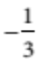
E 3

[1 mark]
5 Find the x-intercepts of p(x)  2x3  9x2  5x
A  5, 0,
B 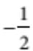, 0, 5
C 0, 1, 5
D 0, 2, 5
E 5, 0, 2

[1 mark]

Part B
7 short answer questions
49 marks
Show your working where appropriate.
1 Sketch the following graphs and state their domain and range.
a x2  y2  9
b y2  2x
c y  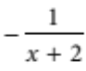
d y  (x  2)(x 1 1)(x 1 2)
e f(x)  (x  4)2
[15 marks]
2 Find the equation of each of the following.
a The line with x-intercept 4 and gradient 3.

b The quadratic function with turning point (2, 1) and y-intercept 11.

c The circle with centre (3, 2) and radius 2.

[9 marks]
3 For the function f(x)  x3  4x:
a prove that the function is odd

b evaluate f(1)

c find the x- and y-intercepts of the function

d sketch the function.

[7 marks]
4 For the given points A(2, 3) and B(1, 4):
a find the midpoint M of A and B

b find the distance between A and B

c find the gradient of line AB.

[6 marks]
5 For the function y  x2  4x  5:
a find the discriminant and state the number and type of its zeros

b find the equation of its axis of symmetry

c find the coordinates of its turning point and state whether it is a maximum or minimum.

[6 marks]
6 Find the radius and the coordinates of the centre of the circle
x2  4x  y2  6y  12  0.

[4 marks]
7 Prove that the line y  3x  1 and 6x  2y  5  0 are parallel.

[2 marks]

Part C
2 analysis questions
16 marks
Show your working where appropriate.
1 For the function y  ax2  bx  c:
a state the x-intercepts

b show that the equation of the axis of symmetry is x  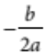.

[4 marks]
2 a Show that the line 3x  4y  5  0 passes through the circle x2  y2  25 at two points.

b Find these points of intersection correct to one decimal place (you may use a CAS calculator).

[12 marks]
Total marks: 60

Answers
Part A [1 mark each]
1 For A, C, D, and E, there is only one y-value for every x value. In B an x-value can take on two different
y-values, e.g. when x  1, y  0 or 7.
∴ B [1 mark]
2 The data is continuous for all functions except C where x2  5 ≠ 0. There are asymptotes at
x 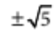and the function is discontinuous at these points.
∴ C [1 mark]
3 y  (x  2)3 is a horizontal translation of y  x3 by 2 units to the right.
y  x3  3 is a vertical translation of y  x3 by 3 units upwards.
So y  (x  2)3  3 moves the function 2 units to the right and 3 units up.
∴ C [1 mark]
4 Writing 2x  6y  1  0 in gradientintercept form:
6y  2x  1
y  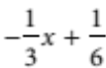
Gradient m1 
For perpendicular lines: m1m2  1
So m2  3
∴ E [1 mark]
5 For x-intercepts, f(x)  0 (y  0)
2x3  9x2  5x  0
x(2x2  9x  5)  0
x(2x  1)(x  5)  0
x  0, 2x  1  0, x  5  0
x  0, , 5
∴ A [1 mark]

Part B
1 a This is a circle with centre (0, 0) and radius 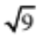 or 3 units.
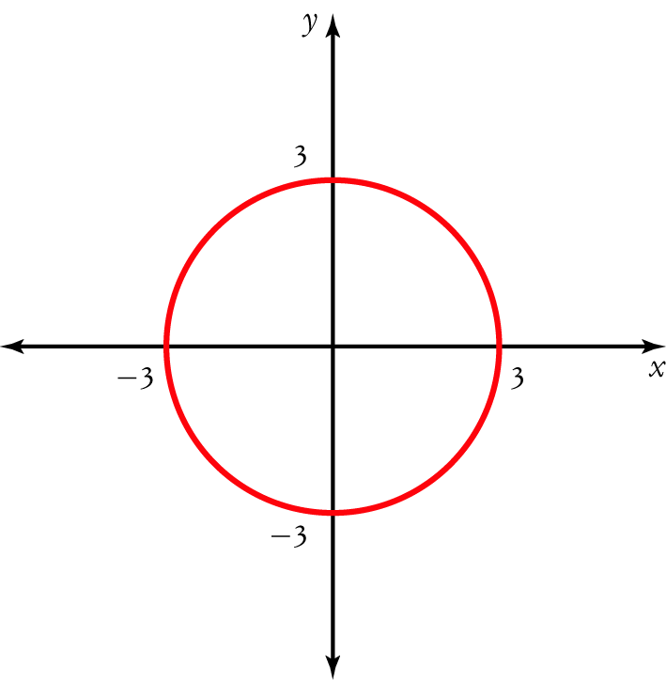
[1 mark]
Domain is {x: 3 ≤ x ≤ 3}; range is {y: 3 ≤ y ≤ 3}. [1 mark]
b This is a parabola with a horizontal axis of symmetry.
y2  2x gives two functions y  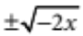, where x ≤ 0.
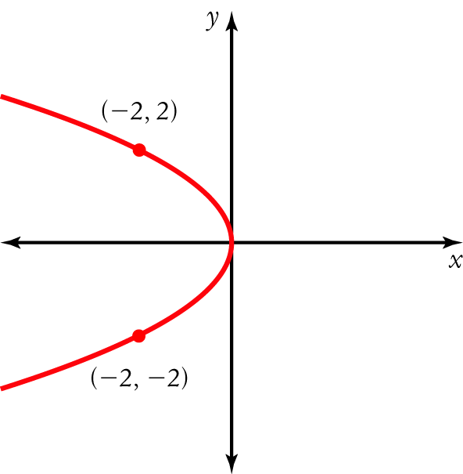
[2 marks]
Domain is {x: all real x ≤ 0}; range is {y: all real y}. [1 mark]
You could write this as domain: ( ∞, 0], range: {y: y ∈ R}.

c This is a hyperbola in the 2nd and 4th quadrants with asymptotes at x = 2 and y = 0.
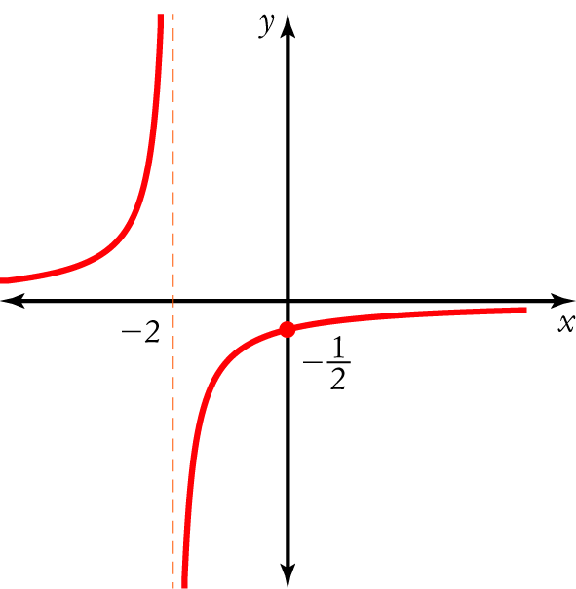
[2 marks]
Domain is {x: all real x ≠ 2}; range is {y: all real y ≠ 0}. [1 mark]
You could write this as domain: {x: x ∈ R\{2}}, range: {y: y ∈ R\{0}}.
d This is a cubic function (polynomial of degree 3) with x-intercepts where:
(x  2)(x + 1)(x + 2)  0
x  2, 1, 2
For x  2: y  0
For 1  x  2: y  0
For 2  x  1: y  0
For x  2: y  0
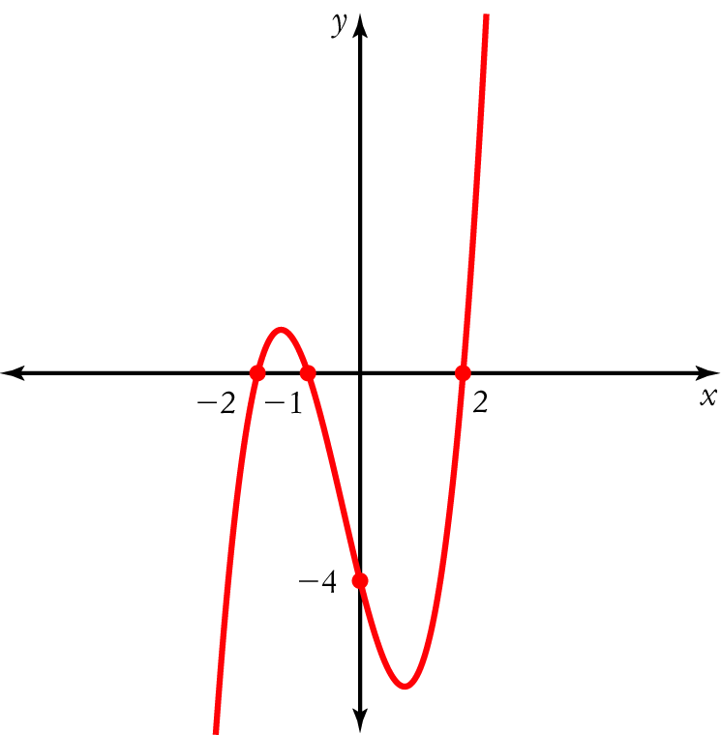
[3 marks]
Domain is {x: all real x}; range is {y: all real y}. [1 mark]
You could write this as domain: {x: x ∈ R}, range: {y: y ∈ R}.

e This is a parabola with x-intercept 4 and turning point (4, 0). It is a horizontal translation of y  x2 by 4 units to the right.
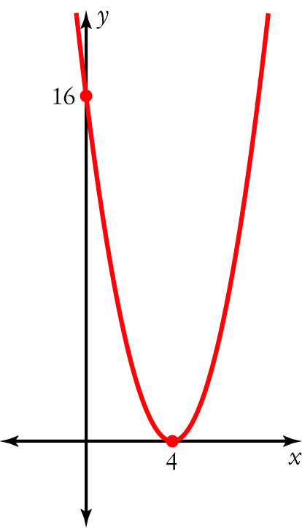
[2 marks]
Domain is {x: all real x}; range is {y: all real y $ 0}. [1 mark]
You could write this as domain: {x: x R}, range: (0, `].
2 a Substitute m  3, (4, 0) into y  y1  m(x  x1)
y  0  3(x  4) [1 mark]
y  3x  12 [1 mark]
or 3x  y  12  0
b Substitute (2, 1) into y  a(x  b)2  c
y  a[x  (2)]2  (1)
y  a(x  2)2  1 [1 mark]
Substitute (0, 11) into y  a(x  2)2  1
11  a(0  2)2  1 [1 mark]
12  4a
3  a
y  3(x  2)2  1 [1 mark]
 3(x2  4x  4)  1
 3x2  12x  12  1
y  3x2  12x  11 [1 mark]
c Substitute r  2 and (3, 2) into (x  a)2  (y  b)2  r2
[x  (3)]2  (y  2)2  22 [1 mark]
(x  3)2  (y  2)2  4
x2  6x  9  y2  4y  4  4 [1 mark]
x2  6x  y2  4y  13  4
x2  6x  y2  4y  9  0 [1 mark]

3 a f(x)  (x)3  4(x)
 x3 + 4x
  (x3  4x) [1 mark]
 f(x)
Since f(x)  f(x). the function is odd. [1 mark]
b f(1)  (1)3  4 (1)  3 [1 mark]
c When x  0:
f(0)  (0)3  4(0)  0
So y-intercept is 0. [1 mark]
When y  0:
0  x3  4x
 x(x2  4)
x  0, x2  4  0
x  0, x   2 [1 mark]
d 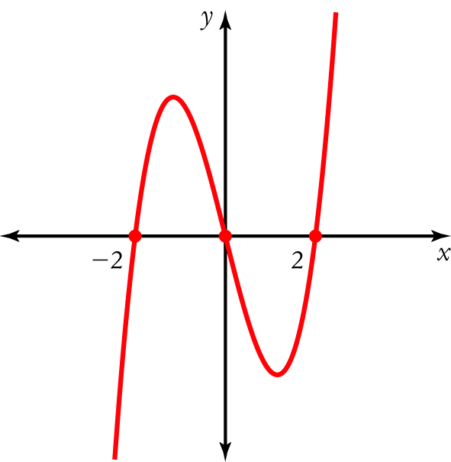
[2 marks]
4 a M  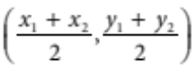
 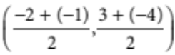 [1 mark]
 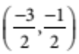
 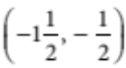 [1 mark]

b 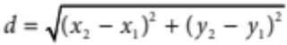
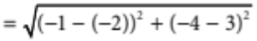 [1 mark]
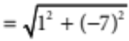
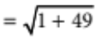
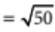
= 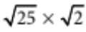
= 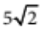 units [1 mark]
c 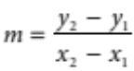
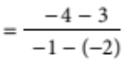 [1 mark]
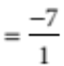
 7 [1 mark]
5 a   b2  4ac
 (4)2  4(1)( 5) [1 mark]
 36 [1 mark]
Since  > 0 and is a perfect square, there are 2 rational zeros. [1 mark]
b x 
 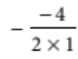
 2
The axis of symmetry has the equation x  2. [1 mark]
c Substitute x  2.
y  22  4(2)  5
 9
The turning point is (2, 9). [1 mark]
It is a minimum since a > 0 (a  1). [1 mark]
6 x2  4x  y2  6y  12  0
x2  4x  y2  6y  12
x2  4x  4  y2  6y  9  12  4  9 [1 mark]
(x  2)2  (y  3)2  25 [1 mark]
[x  (2)]2  (y  3)2  52
This is in the form (x  a)2  (y  b)2  r2
Radius is 5 units. [1 mark]
Centre is (2, 3). [1 mark]
7 y  3x  1 has m1  3
6x  2y  5  0
6x  5  2y
3x  2.5  y
m2  3 [1 mark]
Since m1  m2, the lines are parallel. [1 mark]
Part C
1 a y  ax2  bx  c has x-intercepts at y  0.
For ax2  bx  c  0, x  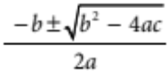 [1 mark]
b The axis of symmetry is halfway between the x-intercepts x1 and x2, i.e., 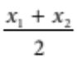
x  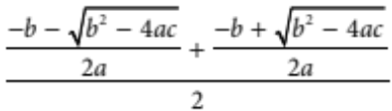 [1 mark]
 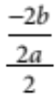 [1 mark]
 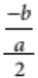
 [1 mark]
2 a 3x  4y  5  0 [1]
x2  y2  25 [2]
From [1]:
3x  5  4y
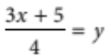 [3] [1 mark]
Substitute [3] into [2]:
x2  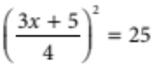 [1 mark]
x2  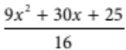  25
16x2  9x2  30x  25  400
25x2  30x  375  0 [1 mark]
5x2  6x  75  0
  b2  4ac
 62  4(5)( 75)
 1536
> 0 (2 zeros)
The line crosses the circle at 2 points. [1 mark]
b On the CAS calculator sketch y  5x2  6x  75 and find the x-intercepts where y  0.
Namely, 5x2  6x  75  0 [1 mark]
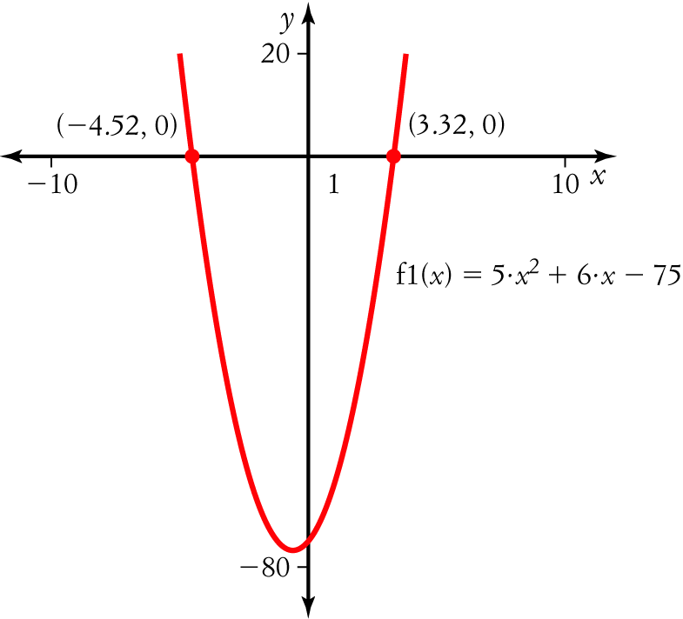
x  4.5, 3.3 [2 marks]
Substitute x  4.5 into 3x  4y  5  0
3(4.5)  4y  5  0 [1 mark]
4y  8.5  0
8.5  4y
2.1  y [1 mark]
Substitute x  3.3 into 3x  4y  5  0.
3(3.3)  4y  5  0 [1 mark]
− 4y  14.9  0
14.9  4y
3.7  y [1 mark]
The points of intersection are (4.5, 2.1) and (3.3, 3.7). [1 mark]

